Software Design and Development

Stage II Submission

Edward Webb

## Data Dictionary

|  |  |
| --- | --- |
| Variable Name | Description |
| time | The amount of time the projectile travelled before landing. |
| initVelo | The projectile’s initial velocity. |
| angle | The angle the projectile was launched from the horizontal. |
| xVelocity | The x (horizontal) component of the projectile’s initial velocity. |
| yVelocity | The y (vertical) component of the projectile’s initial velocity. |
| timeSpecific | The time the projectile took from launch to reach maximum height. |
| timeSpecific2 | The time the projectile took to land from maximum height. |
| maxHeight | The projectile’s maximum height it reached. |
| range | The horizontal distance the projectile travelled from its launch to its landing point. |
| divisor | A temporary variable used to find the angle of the projectile for the 2nd Algorithm. |
| height | The projectile’s initial height from the ground. (Always given by the user) |
| heightEnd | The projectile’s landing height from the ground. (Always given by the user) |
| heightDiff | The difference in height between the landing height and the initial height (heightEnd – height = heightDiff) |
| angleR | The angle from the horizontal the projectile was launched at converted to radians. |

## Screen Designs

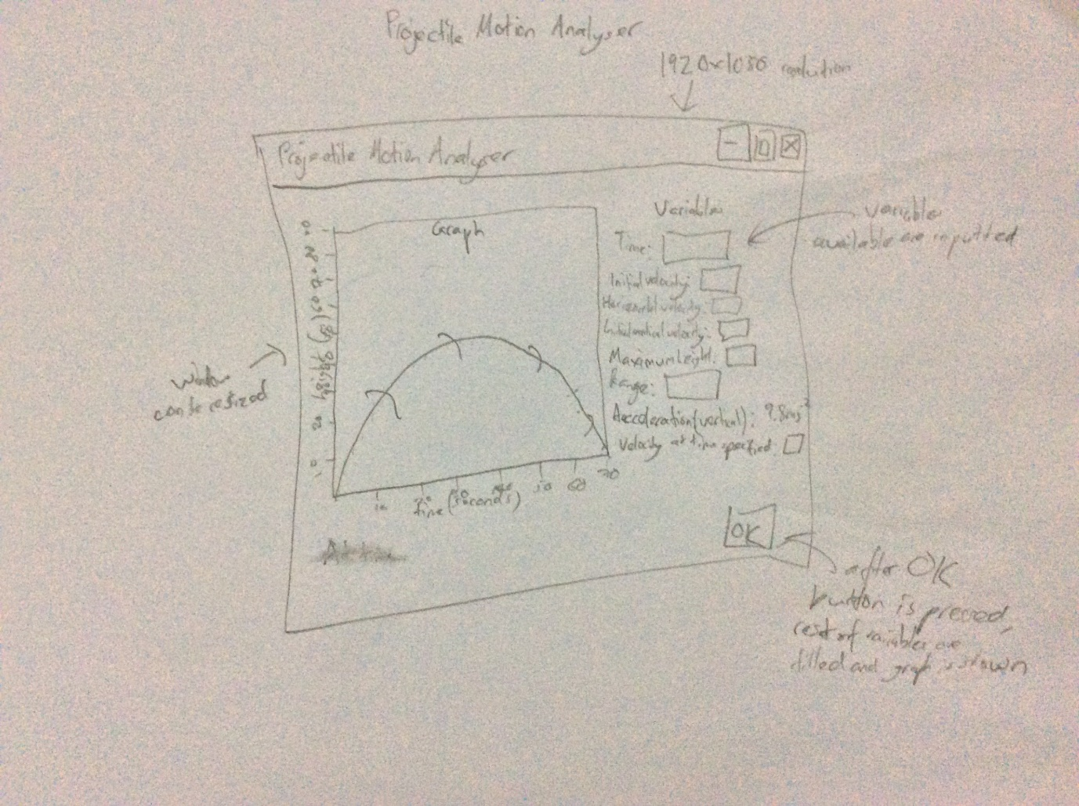Storyboard:

Actual screen design:

